**Q1.**.Discuss the prototyping model? What is the effect of designing a prototype on the overall cost of the project?

Ans-The Prototyping Model is **one of the most popularly used Software Development Life Cycle Models** (SDLC models). This model is used when the customers do not know the exact project requirements beforehand.

It **displays the functionality of the product under development, but may not actually hold the exact logic of the original software.**

The effect of designing a prototype on the overall cost of a software project is to actually **reduce the additional costs of restructuring and reframing it after its full-fledged development**- which might cost a fortune

**Q2.**Compare iterative enhancement model and evolutionary process model?

Ans: **Ans.**Iterative Enhancement Model: This model has the similar phases as the waterfall model, but with fewer restrictions. In general the phases occur in the same order as in the waterfall model but these may be conducted in several cycles. A utilizable product is released at the end of the each cycle with each release providing additional functionality.

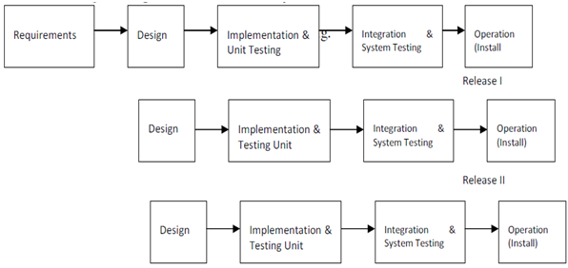

Evolutionary Development Model: Evolutionary development model bear a resemblance to iterative enhancement model. The similar phases as defined for the waterfall model occur here in a cyclical fashion. This model is different from iterative enhancement model in the sense that this doesn't require a useable product at the end of each cycle. In evolutionary development requirements are implemented by category rather than by priority.

Q3.As we move outward along with process flow path of the spiral model, what can we say about software that is being developed or maintained?

Ans: As work moves outward on the spiral, the product moves toward a more complete state and the level of abstraction at which work is performed is reduced (i.e., implementation specific work accelerates as we move further from the origin)

## Q4. Explain the Scrum Agile method?

## Ans: Scrum Agile methodology is a sprint-based project management system with the goal of delivering the highest value to stakeholders.

* Agile and scrum are two similar project management systems with a few key differences.
* Agile is more flexible and promotes leadership teams, while scrum is more rigid and promotes cross-functional teams.
* Agile lets teams develop projects in small increments called “sprints” and allows for more effective collaborations among teams working on complex projects.

Agile scrum methodology is used by companies of all sizes for its ability to provide high-end collaboration and efficiency for project-based work. Agile and scrum are two different methods and can be used separately; however, their combined benefits make the agile scrum methodology the most popular use of agile. Here’s the complete guide to agile scrum methodology.

Q.5 Explain the utility of Kanban CFD reports.

Ans: Cumulative Flow Diagram (or the CFD)  
  
The CFD is **a time-based plot of the cards as they move from the left to the right on a Kanban board**. As cards start from the Ready queue or column, the CFD plots the number of cards at each stage of the Kanban workflow or value stream.